Version 2.6

June, 2024

Steelcase inc

901 44th street se, grand rapids, mi 499508



Supplier Manual

Americas Region

**DOCUMENT CHANGE CONTROL**

|  |  |  |  |
| --- | --- | --- | --- |
| Version Number | Date | Section | Description |
| 2.0 | 6/1/2017 | ALL | Complete re-issue. FG and Direct combined. |
| 2.1 | 6/12/2017 | 4.8 | Mock Up Process added. |
| 2.2 | 9/1/2018 | N/A | Document Change Control added |
|  |  | 1.8 | Chargeback Language added to QMN process. |
|  |  | 2.6 | CDIN Process corrected |
|  |  | 4.1 | Long Term Capacity Plan example updated |
|  |  | 5.10 | Re-written |
|  |  | 6.8 | Fin Goods Packaging Label Placement added |
| 2.3 | 9/1/2019 | 7.4 | CTPAT Requirements added |
| 2.4 | 8/1/2022 | ALL | Complete re-issue. FG and Direct combined. |
| 2.5 |  |  |  |
| 2.6 | 2/14/2024 |  | Annual Review |

# START Manual – Steelcase Americas Region

Dear Supplier,

Thank you for accessing our Supply Management Business Process Guide. We are thankful for the strong relationships we have with our suppliers. These relationships are bolstered through documents such as this which ensure a common understanding of how we intend to work together.

The foundation of our relationship is anchored in our core values:

* Act with Integrity
* Tell the Truth
* Keep Commitments
* Treat People with Dignity and Respect
* Promote Positive Relationships
* Protect the Environment
* Excel

Our core values have centered our organization for more than a century and we continue to leverage them in all that we do, including in our work with you.

The Supply Management Business Process Guide covers several critical business areas ranging from Quality and Engineering to Specials and Materials Management, Supply Management, Distribution / Logistics, and Global Requirements. This Guide provides specific instructions – and sets expectations – on how Steelcase and our suppliers conduct business together. As you reference the Guide over the course of our relationship and questions surface, please feel free to reach out to your Supply Management leader who can direct any question to the appropriate subject matter experts.

Thank you for all that you do for Steelcase!

Best regards,

Derek Ludwig

V.P., Chief Procurement Officer, Global Supply Management

DEFINITIONS :

**Direct Materials:** These are raw materials or components that directly become part of a finished product. They can be easily traced and quantified in the final good. For example, screws, casters, and plastic components.

**Vended Finished Goods:** These are items that a company purchases in a ready-to-sell state and then resells to customers without any further modification. They are not manufactured by Steelcase. Examples include Height Adjustable Desks.

**MRO (Maintenance, Repair, and Operations):** These are supplies that are used to keep a company's operations running smoothly but don't directly become part of the finished product. They are typically consumed during the production process. Examples include lubricants, cleaning supplies, and light bulbs.

**Special Product :** A special is any modification of a standard Steelcase product, which in any way alters the original design. This includes all aesthetic changes such as finishes and fabric. If requested by the Supply Management Specials Team a quote that represents a one for one equivalent to standard product must be returned with a quote number within 24 hours of receipt.

**Custom Product :** is defined as a product that is not a modification to an existing style number or product but rather a completely unique design.

|  |  |  |
| --- | --- | --- |
| SECTION 1: QUALITY  1.1 Production Part Approval Process (PPAP)  1.2 Capability  1.3 Special Process Qualification  1.4 Finish / Coating Qualification  1.5 Custom Surfaces  1.6 Quality, Order Fulfill and Technical Training  1.7 Records  1.8 Quality Management Notifications (QMN’s) Customer Complaint Resolution Process  1.9 Percent Defective Measure  1.10 Priority Inspection Process (Finished Goods)  1.11 Quality Acceptance Standards  SECTION 2: ENGINEERING  2.1 Tooling Readiness  2.2 Product Testing  2.3 Packaging Design and Testing  2.4 Design / Design Change Process  2.5 Small Parts / Hardware Identification (Blue Ribbon Process)  2.6 Controlled Document Issue Notification (CDIN) Process  2.7 Labeling Requirements  2.8 New Fabric Introduction  2.9 Shelf Life / Life Duration  SECTION 3: MATERIALS MANAGEMENT / ORDER FULFILLMENT  3.1 Capacity Planning  3.2 Database Loading  3.3 Order / Change Process  3.4 Plant Shutdowns  3.5 Restricted Schedule Requests  3.6 Systems Paper Test  3.7 Returned Goods Authorization (RGA) Process  8.8 Mock Up Process (Finished Goods)  SECTION 4: SUPPLY CHAIN MANAGEMENT  4.1 Crisis Management + Cyber Security Plan  4.2 Financial Assessment Process  4.3 Master Purchasing Agreement (MPA)  4.4 Schedule of Product (SOP)  4.5 Supplier Certificates of Insurance  4.6 Supplier Technology Requirements  4.7 Invoicing and Accounts Payable  4.8 Supplier Performance Measurement  4.9 Supplier Business Reviews  4.10 Steelcase Sustainability Initiatives  SECTION 5: DISTRIBUTION AND LOGISTICS  5.1 For Purchase Orders  5.2 Expedite Purchase Order Shipments (Direct Materials & MRO)  5.3 Expedite Vended Finished Goods Purchase Order Shipments  5.4 Returnable Dunnage, how to request more?  5.5 Shipping PO Destinations at Steelcase Inc.  5.6 Product Labeling & Shipping Documentation Requirements.  SECTION 6: GLOBAL REQUIREMENTS  6.1 Global Business Standards  6.2 Free Trade Agreements  6.3 US Federal Government Requirements  6.4 Customs Trade Partner Against Terrorism Requirements  6.5 Forced Labor  EXHIBITS   1. PPAP Requirements Checklist 2. Control Plan 3. Quality Management Notification (QMN) 4. Quality Acceptance Standard (QAS) 5. Controlled Document Issue notification (CDIN) 6. Long Term Capacity Plan |  |  |

## Section 1: Quality

* 1. **Production Part Approval Process (PPAP)**

**Definition**

Steelcase’s Purchase Part Approval Process is roughly equivalent in content to the Production Part Approval Process utilized in the automotive industry. If you are a supplier to the automotive industry and already submitting PPAP documents to your customer, Steelcase will accept the format of those documents and records as equivalent. Steelcase considers AIAG (Automotive Industry Action Group) and its PPAP requirements to be interchangeable.

**Purpose**

The purpose of this Product Part Approval Process is to determine if all Steelcase specifications and requirements are properly understood by the supplier, and that the supplier’s processes have the potential to continually produce product meeting these requirements during an actual production run at the quoted capacity. *If there is a temporary process in place prior to full production process, both processes must be qualified before product is shipped to Steelcase (or customer).*

An assessment by Engineering/Quality should be done in the following situations to determine if a PPAP should be initiated:

* + New or revised product configuration
  + New or revised tooling and equipment (excludes normal maintenance)
  + Tooling and equipment relocation
  + New or revised manufacturing process (excludes normal adjustments)
  + New manufacturer or tier II.
  + Material change

Steelcase PPAPs are processed using Windchill ProjectLink.

Windchill workflow generated emails requesting the completion of a PPAP will be received by the supplier.

This email contains links into the Windchill system to access the PPAP. The items below are shown in the image of the email template shown below.

1. The Windchill workflow PPAP task

2. The PPAP request document

3. Detailed walkthrough instructions for PPAP submission

4. Request for Windchill license

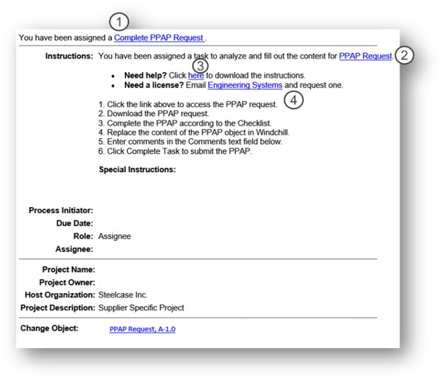

Production Part Approval Packages can include the following:

* Failure Mode & Effects Analysis
* Work Instructions
* Control Plan
* Process Capability Studies
* On-Going Capability Plan (incl.
* Gage Studies / Measurement System Analysis
* Third Party Service
* Run at Rate
* Part Submission Warrant
* Sample Product
* Design Records
* ISIR Layout Results
* Start-Up Pack for Textiles
* Test Results / Certifications
* Process Maps / Diagrams
* Other requirements as needed:
  + Appearance Approvals
  + Special Process Parameter Validation Records
  + Gage, Fixture & Equipment Calibration Records
  + Bill of Material Audits

The **PPAP Checklist** is the tool used by Steelcase to communicate the requirements that will lead to approval of the PPAP. Other items may be required as applicable.

**View PPAP Checklist Example**

**Part Submission Warrant**

* Supplier is to complete all areas of warrant: manufacturing information, reason for submission, requested submission level, submission results, and declaration.
* Steelcase Quality is responsible for disposition of the warrant.
* This document is for part / product approval only.
* The PPAP is not considered complete or approved until this warrant is signed and returned to the supplier.

**Initial Sample Inspection Report (ISIR)**

* Steelcase Product Engineering and Quality are responsible to designate required dimensions to be measured on the ISIR.
  + All KDFs (Key Design Features) are required.
  + The supplier is responsible for measuring with appropriate measurement tools and documenting results.
  + Parts from each position of a multiple cavity die, mold, tool, or pattern are to be measured and representative parts inspected.
  + The ISIR layout report is submitted to the latest revision of the Steelcase print.
  + A copy of the print must be numbered to correspond to the layout results sheet.
  + Steelcase Product Engineering is responsible for dispositioning the ISIR.
* Supplier may be required to provide parts measured for ISIR to Steelcase.
* Steelcase accepts the AIAG PPAP or can provide standardized forms.

**Run at Rate**

Run at Rate is a pre-production run of parts/assemblies performed to ensure that the planned production system (people, processes, equipment, etc.) will produce an appropriate quantity of acceptable products when run at the planned production rate.

**Control Plan Requirements**

Steelcase strongly recommends the use of Control Plans for all our supplied products but will indicate clearly when a Control Plan is considered an absolute requirement for production part or product approval.

The Control Planis an agreement between Steelcase and the supplier which documents how the supplier will meet product requirements for parts purchased by Steelcase. The Control Plan is to be submitted for review to the respective Steelcase QA for approval, and must contain the following minimum criteria:

* Supplier’s name
* Steelcase part name, and number or part family
* Dimensions with tolerances, engineering specs, & aesthetics (if applicable)
* All Key Design Features (KDF’s) noted on the print shown as a diamond with a # in the middle.
* Method of inspection: Calipers, gages, visual verification, etc...
* Number of samples checked and frequency of checks
* Data requirements (charts, daily logs, pre-control charts etc.)
* Implementation date (date Control Plan goes into effect)
* Supplier signature and date of approval or date of change. Data from control plans must be available upon request.
* Records of Quality checks required to be retained
* Steelcase reserves the right to request records of inspections, as detailed in the control plan, at any time.
* Measuring equipment/tools used for inspection of product should follow the 10:1 rule. The 10:1 rule suggests using a measuring instrument that has ten times the resolution as compared to the component tolerance (if the product tolerance is +/-0.001", use a micrometer with 0.0001" graduations)

Reaction plan for non-conformances

Ongoing capability plan established for all VC2 KDF’s

Packaging instructions should also be included

Contact your Steelcase Quality representative if you would like to use the following Steelcase forms: Part submission warrant, ISIR, FMEA, Capability study report & Control Plan.

**View Control Plan Example**

* 1. **Capability**

**Ongoing Capability Plan (OCP)**

Suppliers may need to maintain ongoing process capability on specific dimensions deemed to be critical to the functionality of the final product. Steelcase will specify which product dimensions or attributes require ongoing capability in considering input from the supplier. This initial capability needs to be established as part of the first production part approvals. A plan for sustaining ongoing capability must be in place to support KDF (Key Design Features) requirements. This plan should be supported with a frequency established in the control plan, with SPC data, or a process defined in the supplier’s quality manual.

* Key Design Features: (Shown on the print as a diamond with a # in the middle)
  + DI design intent
  + VC1 = Variation Control 1
    - Requires process to be qualified to a Cpk of 1.00
  + VC2 = Variation Control 2
    - Requires process to be qualified to a Cpk of 1.33
    - Ongoing capability monitoring is required

A proper capability study is completed by using the production tooling/equipment in the production environment. There should be 30 consecutive numbered pieces.

* 1. **Special Process Qualification**

Suppliers should perform process qualification by routine destruct testing on processes such as:

* Welding
* Adhesives
* Plastics

All critical process parameters should be documented on a control plan or process sheet, and on-going destruct testing should be performed to ensure that the processes are being performed properly. Parameters are developed by establishing high and low range of all critical process parameters and verified through destruct testing. Any changes to the parameters outside of the established ranges require re-qualification.

* 1. **Finish / Coating Qualification**

**Finish Specification**

**(For suppliers with internal finishing capabilities or receiving coated parts from a tier 2 supplier.)**

Suppliers will be required to obtain paint line qualification per Engineering Specification ES 1-01-01, or veneer finishing qualification per Engineering Specification ES 3-82-25. Steelcase Finishing Technology group will work with the supplier to ensure appropriate samples are submitted, and paint line settings and controls are documented. Steelcase expects suppliers to maintain control of their finish processes through appropriate measurement and documentation.

Suppliers will receive finish masters issued by Steelcase for each finish offered. In some cases, the supplier may create the masters and submit them for Steelcase approval. Production aids can be produced by the supplier or ordered through Steelcase.

Suppliers are responsible to manage the expiration date on Steelcase issued production masters. Replacement masters are available at this link. [request master](http://syncapps.steelcase.com/supplysyncapps/steelcaserfq/public/MasterProductionForm/MasterProductionOrderForm.aspx)

Finishes must pass all required testing defined by Steelcase for the specific product application.

Tier I suppliers are expected to manage their tier II suppliers in accordance with all Steelcase requirements. Please inform us of any change in your Tier II’s manufacturing process, materials used, or location of manufacturing before implementation. We reserve the right to request new initial samples in connection with any such change.

* 1. **Custom Surfaces**

**Customer’s Own Material (COM)**

Select Steelcase seating and furniture products accommodate hundreds of textiles from many leading fabric suppliers. With the Customer’s Own Material web tool, dealers can find a textile that has already been tested and approved on our product, or they can submit a request to have a new fabric tested.

**PerfectMatch**

The Perfect Match program allows customers to specify their own color on Steelcase painted products where the PerfectMatch option is offered. See the individual Product Specification Guide for available options.

The PerfectMatch program supports matching Steelcase paint finishes that have been “culled” but does not support matching Steelcase “transitional” paints that are not available on select product lines.

All colors will be matched in a smooth, 40% gloss, non-metallic finish or in a textured, 6% gloss, non-metallic finish.

Metallic paint matches for custom or culled Steelcase colors are not available through the Perfect Match program, but can be matched in the standard 40% gloss, opaque (non-metallic), finish.

Steelcase Finishing Technology will approve the coating material with the chosen vendor using the same process for standard color matches. The supplier applying the custom finish will be notified by the Steelcase Finishing Technology representative when the material is approved and will order the coating material as normally done. Provided the supplier has been qualified to apply the material, there are no additional approvals required.

**Customiz**

The Customiz Stain program offers the customer the opportunity to specify a custom-matched stain in a Steelcase wood environment.

The supplier will be notified of the need to match the custom stain color by the Wood Finishing Technology representative who will send a color master and the formula for the color. The supplier will be required to submit production samples just as with standard finishes which will be approved by Finishing Technology prior to the purchase order being sent to the supplier**.**

* 1. **Quality, Order Fulfill and Technical Training**

**Training Available from Steelcase**

All suppliers are expected to complete the QLT275 Steelcase Quality Expectations Course. This course provides an overview of Steelcase’s quality expectations and the requirements and documents associated with gaining and maintaining Steelcase production part approval.

For questions on available training, contact your Steelcase Supply Management representative.

**1.7** **Records**

Steelcase reserves the right to request any of the following documents based on these identified retention periods.

* Production Part Approval (PPAP’s) – retain throughout product life
* In process inspection / test records – minimum one year
* Product test records (e.g., BIFMA) retained throughout product life.
* Documents supporting product traceability, such as adhesive shelf life, incoming material certifications – minimum one year.

**1.8** **Quality Management Notifications (QMN’s) Customer Complaint Resolution Process**

A Quality Management Notification is a communication tool used to document and follow-through on a variety of topics between the Supplier and Steelcase. Some examples where a QMN may be used are:

* Customer Complaint resolution
* Corrective actions / nonconformances
* Failure to respond to a Controlled Document Issue Notifications (CDINs).
* Temporary deviations
* Action Items created during a Partnership Performance Review
* Audit Result action items
* Accumulated rejects
* Service-related issues such as late deliveries and missing or inaccurate paperwork
* Line Shut Down
* Field Failure Cost
* Delinquent corrective action requests
* Import export non-compliance

**Customer Complaint Receipt**

Steelcase will manage all complaints received from customers and will communicate them to the supplier as appropriate. If the supplier receives a complaint notification directly from a customer or dealer, they must direct the caller to 1-800-Steelcase.

**Corrective Action Process**

The supplier will be responsible for working with Steelcase to identify root cause of any product, order fulfillment or compliance problem. The Steelcase personnel responsible for the specific product will notify the supplier and coordinate the resolution of the issue through the Quality Management Notification (QMN) process.

**QMN process:**

**1) Identify Nonconformance**

The flow chart shown in this section assumes that Steelcase identifies the nonconformance. This process also applies to any nonconformance found by the supplier.

**2) Quality Management Notification Issued**

A Steelcase representative will document the nonconformance using a QMN and communicate to the Supplier representative. The QMN is time stamped and includes a requested response date. Quality Management Notifications issued to suppliers may include fees for costs incurred relating to any Steelcase or customer disruption.

Per the provisions for Nonconforming Products and Set Offs contained in your contract with Steelcase, we reserve the right to charge back the reasonable costs associated with the processing and replacement of nonconforming products. These charges will be documented in the QMN and must be approved by the Supply Chain Lead responsible for the supply relationship. All charges will be discussed with the supplier in advance and will be assessed in accordance with the severity of the nonconformance and the corrective action required.

**3) Isolate / Verify Outgoing Orders**

The first step in the containment of a nonconformance is to isolate the suspect product and verify the acceptable product prior to shipping. When circumstances dictate that additional inspection must be implemented Steelcase will have the right to choose from the following options :

1) Assure Steelcase of a verifiable final inspection process at the supplier’s facility using supplier resources.  Steelcase may audit and or require documentation that confirms expectations are met;

2) Contract with a third-party company to provide inspection services at Steelcase or the supplier for which the supplier will bear the cost;

3) By exception, Steelcase will hire the required resources and back-charge the supplier for inspection services.

**4) Isolate / Verify Work in Process and Stock Materials**

It is crucial that all work in process specifically related to the nonconformance be quarantined. Verification of WIP is not required within the first 24 hours of receiving the QMN as long as interim measures for detection and sorting have been satisfactorily implemented.

**5) Other Short-Term Actions**

Other short-term actions for detection / sorting must be identified in order to prevent shipment of nonconforming products while permanent corrective action is determined and implemented. Actions such as increased inspection frequency, process / product auditing, department / team meetings or Quality notifications are appropriate.

**6) Respond to QMN for Short Term Actions**

Once the short-term actions are identified, the Supplier must respond to the Steelcase Quality representative. The target for the short-term response is 24 hours.

**7) Long Term Corrective Action**

Identify Root Cause

Using whatever process is appropriate or common at the Supplier; the root cause must be identified and included in the submitted Corrective action. Acceptable tools for identifying corrective action include 8D, DMAIC, fishbone diagrams, FMEA, PFMEA, DFEMA.

Develop Corrective Action(s)  
A single or series of corrective actions required to address the nonconformance in a *global* sense is developed in a manner acceptable to Steelcase. Documentation and training should always be considered in the corrective action response.

Develop Measures of Effectiveness

It is required to define and document the methods for verification of effectiveness of the corrective action.

Respond to QMN

Steelcase expects a corrective action response to be submitted within the targeted time frame listed on ~~all~~ the QMN. This requirement does not include implementation of corrective action only identification of the root cause and plan to resolve including target dates. Responses that do not include Measures of Effectiveness will not be accepted.

**Note: Failure to respond within the requested time frame may result in an additional QMN and fees.**

Fees and charges will be assessed for QMNs as appropriate and determined by Steelcase Quality and Supply Management. These charges cover administrative costs for processing QMNs, and costs Steelcase incurred due to quality problems.

For non-conforming products or late deliveries, a $300 process fee will be charged per item.

Cost(s) incurred by Steelcase related to the QMN may include sorting labor, rework costs, 3rd party containment costs, expedited shipping costs, travel to customer sites, and rework costs at customer. Disruption – downtime caused, scrap caused by material, damaged tooling, or equipment.

Chronic delinquent responses to requested corrective actions or verifications - charge assessed per occurrence for failure to respond within the specified time for corrective action or verification activities. Charge = USD 600.00

Implement / Verify Corrective Action

Steelcase reserves the right to require objective evidence of implementation, such as documentation, pictures, training records, or capability studies. Verification of implementation may also require a site visit by Steelcase personnel.

Verify Corrective Action Effectiveness

Per the corrective action plan, personnel from the supplier or Steelcase must verify the effectiveness of the corrective action. Steelcase reserves the right to require objective evidence or a site visit as verification. Steelcase considers 30 – 60 days an acceptable time frame for verification of effectiveness. Longer time frames can be negotiated case by case.

Close QMN

When the corrective action effectiveness has been verified the QMN will be closed in the Steelcase Quality system.

**View QMN Example**



**8) Steelcase Supplied Parts CAR**

This defines the method to document any rejects on parts supplied from Steelcase Inc to a Steelcase Inc supplier. It may include Corrective Action Requests, cost recovery, utilizing collaboration.

Enter nonconformance to the FORM. [STEELCASE CAR](https://app.smartsheet.com/b/form/6a42cc580efa4e0785a30486eeac80ed)

**1.9** **Percent Defective Measure**

Supplier’s performance is measured using the percent defective

* The percent defective is the number of defective items divided by the total number of items produced.
* Defective quantities are determined from QMN’s issued to the supplier.
* Shipped units are determined by receipts from SAP
* Contact your Supply Management leader for your percent defective goal
* Plants not actively using SAP yet will review supplier performance based on # of QMN’s issued.

**1.10** **Priority Inspection of Product (Finished Goods)**

Priority inspection is a designation given to orders requiring additional confirmation of conformance to requirements.

When the supplier receives an order, the T-markings section of the ship label must be reviewed for any of the following designations:

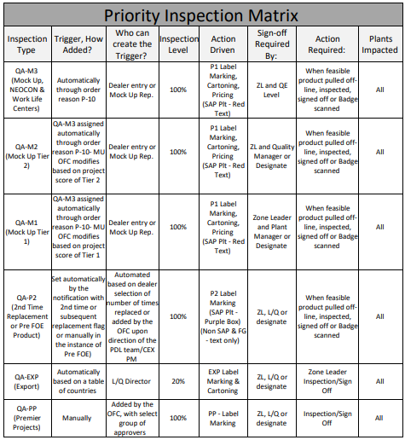

P1 Mock-up Orders – Special orders intended to win new business requiring expedited handling and priority inspection by Quality Assurance. A mock-up order may be a component product or display of completed products. Inspections should include all items on the Mock-up inspection check list.

Mock-up orders are identified as QA-M1, QA-M2 or QA-m3 based on difficulty and importance. The checklist requires different approval levels based on the tier. The inspection requirements are identified on the Mock-up inspection checklist. Tier 1&2 mock-ups require photos of the completed product with the shipping label and completed mock-up inspection checklist to be filed for future reference. Print/copy shipping labels on “rocket red” paper. Inspections should include all items on the Mock-up inspection check list. Link to Mock-up checklist. [Check List Link](https://steelcase.sharepoint.com/sites/SQE/Files/Mock%20Ups/Mock%20up%20cklist_Tier%20Rev.%20A.xlsx?web=1)

P1 Sales related Orders – A P1 sales related order may be a display of products that are ordered by a Dealer to present Steelcase capabilities to a customer.

P2 Replacement Orders – Second time replacement orders requiring priority inspection by Quality Assurance prior to shipment.

Any of the QA-P1 or P2 designations on the ship label indicate that the item is to be handled as a Priority Inspection Unit and should include:

1. Major Project Color Label location (See section 4.6 for more information)

2. QA-P1 (or QA-P2, etc.) Priority inspection indicator and ‘Accepted by’ sign off

3. Mock Up designation (appears for mock up orders only)

The shipping label must be signed off in the “ship to” (left side) and “build” (center) sections, identified with the acceptance by marking.

Records of Priority Inspections may be requested by Steelcase.

**1.11** **Quality Acceptance Standards**

Quality Acceptance Standards (QAS) are illustrated descriptions of Steelcase workmanship requirements for finished products or components. QAS’s may contain certain specifications that are not found on other documents such as label placement, lubrication, surface classification, part/gap relationships, aesthetic guidelines, functional characteristics, shipping and packaging tape, etc.

The Quality Acceptance Standard (QAS) is used in conjunction with engineering drawings, engineering specifications (ES), applicable masters, training, local work instructions, and in some cases, assembly direction sheets, to form the Steelcase requirements for products. QAS documents are developed and issued by Steelcase but must be controlled internally at the supplier.

**View QAS Example**

## Section 2: Engineering

**2.1 Tooling Readiness**

To ensure the supplier is ready for the start of production, any tooling or fixturing requirements must be completed, and asset ownership must be clearly defined.

The supplier is required to properly store and protect Steelcase assets. Asset cost, physical location and name will be provided to property accounting. Steelcase Property accounting will issue an asset number and identification tag. Supplier’s must adhere the identification tag to the Steelcase owned asset or storage container for asset.

The supplier will be required to complete and sign a Tooling and Equipment Exhibit to the Schedule of Product that will detail the tooling’s asset number assigned by Steelcase, the location and other information of the tooling. This Tooling and Equipment Exhibit will be used by Steelcase Property Accounting to conduct capital asset audits on a periodic basis. The supplier will be expected to respond to the tooling audit enquiries promptly.

**2.2 Product Testing**

Steelcase requires all supplied products to meet or exceed BIFMA testing requirements. In addition, packaging and ship testing requirements must be met. These requirements will vary depending on the nature of the product and the method of delivery (i.e. ground transportation, air freight).

Unless otherwise required and specified, Steelcase will be responsible for all product testing and will provide approvals prior to any product launch or design change for products designed by Steelcase. For products jointly designed or designed solely by the supplier, testing responsibilities will be defined in the Schedule of Product and Product Specifications.

Steelcase will periodically conduct compliance testing at Steelcase expense. The testing will take place in the Steelcase Compliance Lab. Compliance audits will include “Fit and Finish” requirements as identified in the products QAS, as well as testing to applicable BIFMA requirements.

Any testing non-conformance issues will be documented via a QMN to the supplier and formal corrective action will be required.

For products with supplier-owned design, and pass-through products (supplier branded); the supplier will be responsible for providing corrective action to return product to all conforming performance requirements. This will be handled by quality utilizing the QMN process.

**2.3 Packaging Design and Testing**

**2.3.1 Direct Materials**

It is the responsibility of the supplier to provide sufficient packaging to prevent damage to the product in transit to Steelcase. The packaging will be approved at Pilot. Changes to packaging require Steelcase approval before implementation.

**2.3.2 Finished Goods Packaging**

It is the responsibility of the supplier to design packaging for Finished Goods that meet the requirements defined in the Steelcase Packaging Specification and Distribution Guidelines **available here.**

Suppliers are required to maintain a packaging Bill of Materials for all Finished Goods products. Any changes to an approved pack must be preauthorized by Steelcase, Inc

*Ship testing can be accomplished by laboratory testing to the specified shipping vibration and drop test specifications at Steelcase or their ASTM/ISTA equivalent or by a Steelcase Over-the-Road test. Steelcase will assist in any ship testing that can’t be done by the supplier in a certified test lab.*

**2.4 Design / Design Change Process**

Design and design change authority will be specified in the Schedule of Product (SOP). Any supplier design change authority ~~Process~~ is to be agreed upon by Supplier and the Engineer responsible for the product and documented in the SOP.

Design Change Authority will include:

• Notification methods

• Approval routing method

• Issue of pertinent documents within the

supplier’s facility

• Level of change requiring notification

• Level of change requiring approval

• Approval authority required

Prior to launch of a product with a supplier, Steelcase is responsible for ensuring that all specifications concerning the product(s) listed on the SOP are current and have been issued to the supplier. Steelcase may request copies of supplier-owned products and process documentation. Generally, a launch readiness review is conducted, and the supplier is expected to raise any issues related to specifications at that time.

These specifications include but are not limited to:

• Technical product specifications

• Process parameters

• Finish materials

• Finishing processes

• Environmental cycle testing

• Quality Acceptance Standards

• Product testing

• Product performance requirements

• Process qualification

• In-process testing

Steelcase will compile and issue all proprietary specifications to the supplier through the Controlled Document Issue Notification (CDIN) process.

*The Supplier is responsible for obtaining and maintaining currency of any industry or national standards required.*

The Supplier is responsible for incorporating all specifications into their product and process documentation where required.

**2.5 Small Parts / Hardware Identification (Blue Ribbon Process) - Finished Goods**

To prevent inadvertent disposal of our product hardware or small parts, Steelcase Inc. requires small parts to be identified by a noticeable length of ribbon attached to the components in question. The tail of the ribbon should be long enough to extend outside of the box to identify the pack as having the hardware included.

The ribbon used is typically known as flagging tape or surveyor's tape; this is available from many sources. Color is not as important as the presence; however, Steelcase has opted to use BLUE as the primary color.

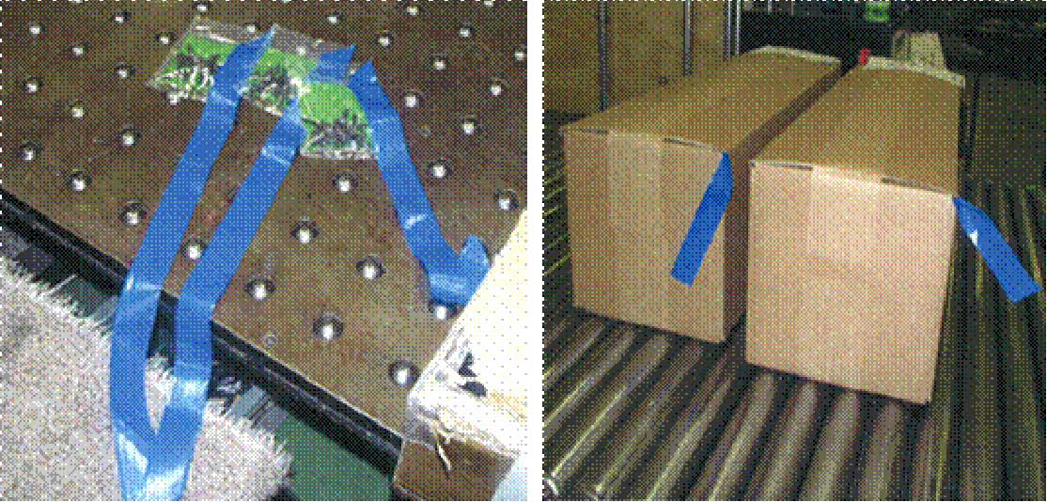

**2.6 Controlled Document Issue Notification (CDIN) Process**

Steelcase is responsible for issuing Steelcase Engineering Release documents to the supplier, and/or notifying the supplier of the change via the Controlled Document Issue Notification (CDIN) process. These documents include but are not limited to:

• Expanded Engineering Releases

• Engineering drawings

• Product structure files

• Engineering, design, test and material specifications

• Quality Acceptance Standards

Suppliers will receive these notifications electronically via SupplySync. Suppliers are responsible to acknowledge the CDIN receipt in SupplySync and ensure the contact information for CDINs in SupplySync is current and correct.

**View CDIN Example**

**2.7 Labeling Requirements**

**2.7.1 Product Identification – Direct Materials**

In all cases, product-labeling requirements must be specified on the engineering drawing. If this is not the case, please inform your Steelcase Engineering or Quality contact for clarification of the requirements.

**2.7.2 Product Identification – Finished Goods**

Product Identification labels are required for every product. Product ID labels are part of the shipping label. The product ID label requirements for use are defined on the Steelcase engineering drawing. The product ID label must be attached to the product in such a way as to ensure removal is intentional. The label must state “Made in (country of origin: US, Canada etc.) with (country of origin) and imported materials.

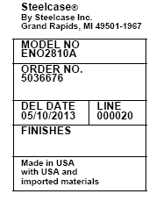

**2.7.3 Plastic Warning Labels**

Plastic bags with opening diameters larger than five inches shall have the following warning statement:

 **WARNING Suffocation hazard, discard this bag after use. Keep this bag away from babies and children. Do not use in cribs, beds, carriages or playpens. This bag is not a toy. The thin film may cling to the nose and mouth and prevent breathing and could result in death or serious injury.**

**See MAT-2000 FOR ACTUAL SIZE**

**2.7.4** **Bedding Law Labels**

Bedding law labels are unique to product content, manufacturing location, and country of destination. If you are a supplier of upholstered items, you will need to provide Steelcase labels for each different combination of contents. These labels will reference your state or provincial bedding and upholstery registration numbers. Each of your individual manufacturing sites must maintain a current upholstery manufacturer registration in all states, and local jurisdictions whose laws require you to do so and provide evidence of current registration upon request. These labels must be applied to each upholstered item as specified on the engineering drawing.

**2.7.5 Flammability Labels**

When the Product Specification or Engineering Drawings require compliance with a Flammability code, the Supplier will be required to apply the pertinent labeling per the Schedule of Product.

**2.8** **New Fabric Introduction**

When new fabric(s) are introduced, the supplier is required to test the fabric for acceptability of their specific application:

* + Identify supplier contact for fabric test. Including: name, email, phone number, address.
  + Supplier contact will be sent fabric for testing and electronic version of acceptability worksheet.
  + Supplier Contact will also be responsible for coordinating product build, filling out the “New Fabric Acceptability Worksheet,” and emailing the results to the Surface Material Technician within one week from fabric receipt.

**2.9** **Shelf Life / Life Duration**

Suppliers of items with a limited shelf life will be required to provide the following in the Life Duration Exhibit:

• Expiration date

• Supplier

• Color identification on each container (if applicable)

• Batch and / or lot number (if applicable)

Batch, lot number and color identification will also be identified on shipping documents as applicable. Suppliers will also identify on product containers any specific requirements for storage to prevent deterioration.

75% of the product’s shelf life must remain upon shipping the product.

## SECTION 3: MATERIALS MANAGEMENT / ORDER FULFILLMENT

**3.1** **Capacity Planning (Sales and Operations Execution – S&OE)**

Suppliers are required to establish inventory requirements based on service level expectations~~,~~ acceptable dollar amounts allocated to inventoried assets, and a clear understanding of the timing of ownership of product. The inventory plan covers unique items kept in stock, lead times, and high and low inventory levels and costs. It is to be included in the Schedule of Product. Steelcase and its suppliers must work together as partners towards a mutual goal of total cost management throughout the supply chain by controlling excess inventory and eliminating waste.

**Schedule Quota**

The base unit of measurement used by Steelcase for capacity planning are Standard Hours or Pieces. The unit of measure for suppliers can be anything that is appropriate to control the capacity.

It is possible that all Steelcase products at a supplier’s facility may have the same Standard Hour value. It is also possible that each SKU will have a different Standard Hour. In certain instances, the supplier may be asked to provide or conduct time studies to estimate or validate data being used to assign Standard Hours.

The marketing forecast will be applied and translated into a total weekly Standard Hour value based on the projected product mix. This is called the Quota. Steelcase loads the Standard Hour value for each product into our product database.

**Planning Buckets**

A scheduling bucket is assigned to each product that a supplier runs for Steelcase. The schedule bucket is used to control the number of products being requested by the customer on a specific day. The scheduling buckets are typically set up in pieces; however, other measurements are usable such as standard hours. Our system auto-schedules based upon the agreed capacity and lead-time for that product line.

**Load Agreements/Long term Capacity Plans/Quota Management**

Steelcase will work with the supplier to develop Load Agreements and a Long-Term Capacity Plan for each product they supply to us.An initial quota will be generated based on a marketing forecast, and the Long-Term Capacity plan will be built from this information.

The Long-Term Capacity Plan form will illustrate Steelcase critical pre-planning information on equipment, facility, and other resource needs based on varying levels of production, using the current quota as the base. The Sales and Operations Execution process involves analyzing specific market indicators to set or re-align manufacturing quotas to meet the market demand. The goal is to meet the customer requested delivery dates 100% of the time.

Steelcase reviews the business data and compares it to the supplier capacity and quotas daily. We will determine the impact to schedules for the supplier and recommend any needed quota changes. This analysis will also help the supplier become aware of possible bottlenecks or other impediments to increased levels of production.

If major changes are indicated, requiring capital equipment, facility moves or large resource changes, the Order Fulfill Manager will coordinate with the supplier and the Supply Chain Lead. Steelcase will also provide ongoing order level and forecasting data to the supplier in the form of Forecast graphs and Planning Bucket summaries daily.

**View Capacity Plan Example**

**Master Planner**

Master planner is a load optimization tool used by Steelcase. Master Planner will move orders based on available capacity while optimizing logistic costs. Order due dates may move from the time they are received until eight days prior to the delivery date (or when the labels print) at Steelcase.

Suppliers will receive only one change notice from Master Planner eight days before ship if the order ship date was changed. The Capacity Manager will analyze the resulting schedule loads and will address any capacity issues with the supplier.

**3.2 Database Loading**

Loading the product database is a Steelcase responsibility; however, the supplier may be required to submit certain product or process information for the calculation of the Standard Hours or pieces, and weights, cubes and pack factor information for shipping.

**3.3 Order / Change Process**

**Order Process**

All orders from Steelcase(except those for MRO) will be communicated via the agreed upon platform (eg: EDI, SUS, or Coupa). The normal method to be used and any allowable exceptions will be documented in the Schedule of Product. The Supplier is permitted to accept orders only from properly authorized Steelcase representatives. Invoices for orders taken without a legitimate Steelcase P.O. number will not be paid.

**Change Order Process**

Definition of a P.O. Change:

Any modification made to a Purchase Order which alters the original instructions in any way.

Timing of a Change:

P.O changes to supplier from Steelcase will be sent automatically (without supplier approval), until the lead-time or label print date has been reached, whichever is greater. If the change request is inside the lead-time or label print, the supplier will be contacted for approval prior to receiving the change.

Communication of a Change:

A Purchase Order will be generated indicating just the net changes made to the original P.O, prior to the label print or lead-time constraints being reached. An email mini form will be used to communicate changes made when inside supplier lead-time or label print date, additionally a phone call will also be placed. Approval or disapproval must be communicated back to the requester within two hours of receiving the change notice. If approved, the P.O change will be made and sent to the supplier.

Who will make the Change:

Steelcase Order Fulfill personnel are the only Steelcase personnel who will be communicating these changes.

**3.4 Plant Shut-downs**

Steelcase requires a list of all dates for the entire year that supplier facilities will be shut down. This list must be inclusive of all planned shut-down days, for any reason. A written plan must be submitted to Steelcase before First Order Entry and on the 1st of every January thereafter, detailing how each supplier will service orders during the shutdown. (A move-up schedule will need to be developed.)

Steelcase Scheduling will require a written notice from all suppliers at least two months in advance of any planned shutdowns not listed on the master shutdown list. Steelcase Supply Management will send a copy of the Steelcase holiday and shipping schedules for the following calendar year to each supplier by the first day of October. If the supplier shut down schedule changes, a copy of the new schedule must be sent to the product Planner at Steelcase.

**3.5 Restricted Schedule Requests**

If a Steelcase Sales Service has a need to add product into a closed schedule (four weeks before shipment), they are required to submit a written request to the Planner of record. Steelcase Order Fulfill personnel are responsible for contacting the supplier with the order information to obtain approval to add product to the closed schedule. Steelcase has a 4-hour turnaround commitment to Sales Services to allow them to meet their turnaround commitment to the customer. Therefore, the supplier will be asked to turn around the request in 2 hours.

If it is not possible to provide the product in the requested ship schedule, the supplier will respond with the best available ship date. Under no circumstances should orders be added to closed schedules without going through this process.

Suppliers finding orders added without previous notification and approval must notify the Planner immediately.

**3.6 Systems Paper Test**

The Systems Paper Test will ideally occur during the New Product Development Process as part of a Pilot Run. However, if the final order process is not in place, or a Pilot Run is not specified, a Test Order will be sent to the supplier and should be processed through the normal order system, including the following:

• Order acknowledgement

• Order Change acknowledgement

• Label print

• Shipping notification

The supplier should also take this opportunity to ensure that internal systems are in place for shop orders, routings, etc.

**3.7 Return Goods Authorization (RGA) Process**

If there is a need to return product to the supplier, the Steelcase Planner or designate will contact the supplier’s order fulfillment representative for an RGA number. This number is used to track the product return and may also be used for invoicing purposes.

**3.8 Mock-Up Process (Finished Goods)**

A mock-up is an opportunity for Steelcase, with our supplier, to differentiate ourselves from our competition. It is a way to secure additional business for both of us by performing to a customer’s request quickly and accurately. Because of the criticality of office furniture industry bid timelines, Mock-Ups will frequently be requested for product to be manufactured in less than standard lead times.

**Mock-up Requirements of our Suppliers**

• Replies to mock-up requests are due back to Steelcase within 2 hours of receipt

• Supporting our mock-up process by carrying inventory of certain items as needed with no extra charge to Steelcase

• Designate personnel to expedite mock-up orders

• Inspect 100% of all mock-ups before ship (see Priority Inspection Process)

• Print/copy shipping labels on “rocket red” paper provided by Steelcase

• Providing evidence of a documented internal process for the manufacture and control of mock-ups throughout the supplier’s facility

• Both the checklist and the mockup shipping label should be signed by the inspector

## SECTION 4: SUPPLY CHAIN MANAGEMENT

**4.1** **Crisis Management Plan**

Steelcase requires that a Crisis Management Plan be drafted by suppliers to ensure that contingency plans are in place to manage possible disruptions in providing product to the customer.

The contingencies covered by the Crisis Management Plan should include, but not be limited to:

* Activities, alternate arrangements, and time lines planned to recover from accidents or acts of God that impact the supplier’s ability to meet customer orders.
* Subjects to be covered include but are not limited to facilities, staff, and information systems.
* Redundant tooling plans and rapid tool build and qualification time frame.
* Description of plans to protect Steelcase owned assets.
* Description of plans to protect Supplier owned, Steelcase specific inventory or other assets.

**Crisis Management Plan (EXAMPLE):**

In the event of (President’s / CEO’s) demise, (replacement) will be named the operations manager. (Other company principals) will set strategic directions and will determine if any staffing changes or additions will be required.

Duplicate tooling is maintained at (alternate facilities).

Computer back up records for all sourced (tier 2) purchase materials and the manufacturing process sheets and control plans are kept at (alternate facilities).

Timeframe required for actions to activate alternative manufacturing arrangements are:



**5.2 Cybersecurity Requirements**

Strengthening IT security must be a high priority to protect all our business relationships.

Cybercriminals constantly look for creative ways to gain access to IT networks, so we need to keep assessing how well we are prepared to withstand cyber-threats.

The following list provides questions to consider when you assess your IT security.

• Does your IT network require 2 factor user authentication?

• Are critical databases securely backed up?

• Are you following any standards like NIST, CIS, ISO27001?

• Do you have a cyber threat consultant on retainer?

• Do you have cyber liability insurance?

• Is there a personnel commitment for security, whether inhouse or outsourced?

• Does your crisis management plan include how you will recover from a cyber-attack?

• Do you have penetration testing of your IT network?

• Do your employees undergo a “phishing detection” training and report suspicious emails?

Regarding cyber insurance, certain preparations are necessary to obtain a policy. These preparations are what reduce cyber risk. Steelcase already requires cyber insurance with some supplier relationships, and this is being expanded to include new agreements with direct material and finished goods suppliers.

Please take all appropriate actions to execute cybersecurity so that our collective business and those of your other business partners are protected.

~~Going forward we anticipate this topic will continue to be critical to our relationship, and we will be interested in understanding how your company is managing cyber risk.  Please feel free to proactively let your Supply Management Lead know how you are already managing this risk as well as improvements in security your company may be planning.~~

**4.2 Financial Assessment Process**

To ensure the financial stability of our supply base Steelcase requires accountant prepared financial statements for the purpose of conducting supplier financial assessments. Summary statistics and financial ratios preclude the development of sufficient insight into financial results, which is a prerequisite to achieving a valid financial assessment.

Financial statements will be kept confidential by the Steelcase Corporate Credit Team, effectively creating a firewall between them and the Supply Management function. Steelcase Corporate Credit will perform a financial assessment (often consulting with the supplier’s Finance leader) and generate a rating which will be given to the Steelcase Supply Management team for use on the Supplier Scorecard. None of the supplier’s financial data will be passed to Steelcase Supply Management team members.

To facilitate Steelcase’s financial assessment please electronically send financial statements to: **statement.drop@steelcase.com**. This is a secure email box accessible only to members of the Steelcase Corporate Credit Team. Upon receipt of the financial statement one of the members of the Steelcase Credit Team will perform the financial assessment.

**4.3** **Master Purchasing Agreement (MPA)**

The Master Purchase Agreement (MPA) is an agreement that outlines our expectations regarding :

• Confidentiality

• Warranty

• Indemnity

• Termination of our contracts

• Subcontracting or transfer of work

• Compliance with legal and regulatory requirements

• Independent parties

**4.4 Schedule of Product (SOP)**

The Schedule of Product (SOP) is a contractual document defining product / project specific terms and conditions. The SOP may be used in conjunction with the Master Purchasing Agreement.

When used, the SOP takes precedence over the MPA and can supersede any contradictory terms stated in the MPA. The hierarchy of purchasing documents is outlined in the Master Purchase Agreement.

With the SOP, we strive to define mutual roles, responsibilities and expectations aimed at providing a solid foundation for a successful long-term relationship.

* Defining liability, warranty, indemnity, and damages related to failure to perform per the contractual obligations;
* Defining the required insurance coverage;
* Defining the process for terminating the Agreements made between us and the supplier;
* Defining applicable law and dispute resolution should there be a dispute;
* Clearly defining the scope of the work/price contracted for;
* Define Steelcase’s and the supplier’s intellectual property interests and avoid claims of infringement;

Maintenance/revision of the SOP document is the responsibility of Steelcase.

Although the MPA and SOP/SOW are the most common contracts with suppliers, many supplier relationships include various other contracts such as, but not limited to:

• Nondisclosure Agreements

• Master Tooling Agreements

• Intellectual Property Agreements

• Consulting Agreements

• Professional Service Agreements,

• And many more

**4.5 Supplier Certificates of Insurance**

Steelcase utilizes a third-party company, (myCOI) to track and verify U.S. located supplier’s insurance coverage, so that the supplier does not have to spend time requesting, collecting or delivering a certificate of insurance (COI) to Steelcase. When Steelcase and the Supplier enter into a Schedule agreement, Supplier will receive an email requesting registration from **certificate.request@myCOIsolution.com**. Suppliers must follow the instructions contained in the email and complete the online registration. Upon completion of registration, myCOI will request proof of insurance directly from the supplier’s insurance agent(s). Once a compliant COI is received by myCOI any future insurance correspondence will be between myCOI and the supplier’s insurance agent(s). As agreed upon, the Supplier will keep a compliant and up to date certificate of insurance (COI) and will notify Steelcase of any change including expiration or cancellation. Override approvals are provided by Steelcase Risk Manager when appropriate to the relationship.

Suppliers located in non-U.S. countries must send their certificates of insurance to [scmcontr@steelcase.com](mailto:scmcontr@steelcase.com) .

**4.6** **Supplier Technology Requirements**

**4.6.1 Electronic Business Transactions**

Each Supplier will communicate with Steelcase via the required electronic transactions based on the business requirements.

Electronic Transaction Exchange Methods:

• XML (eXtensible Markup Language) w/ Steelcase schemas

• EDI (Electronic Data Exchange) w/ Steelcase ANSI standards

• SUS (Supplier Self Service) application in SupplySync

* Coupa

**4.6.2 Technology Platforms**

SupplySync and Coupa are secure web based platforms that connect Steelcase with its suppliers to provide the following:

* Exchange of business transactions (purchase order, ASN, invoice, etc.). See the Electronic Business Transactions section below for more information.
* Accessing demand and inventory information.
* Accessing invoice status, ~~check information,~~ open payables and invoice reconciliation reports.
* Retrieving engineering release information including drawings and revision history status.
* Accessing business process documentation and collaborating with Steelcase personnel.
* Reporting on the status of past due orders.
* Retrieve Vended Finished Goods Labels

As part of the launch process (or at some point in the future) your company may be asked to participate in SupplySync or COUPA. To gain access, your company will work with the Supply Management Enablement team (CSPHelp@STeelcase.com) who will establish a rollout timeline and walk you through the necessary steps to get your company enabled and trained.

If you have questions about SupplySync or Coupa please email CSPHelp@Steelcase.com.

**4.7** **Invoicing and Accounts Payable**

**4.7.1 No Purchase Order, No Pay Rule**

Steelcase Global Policy for supplier invoice processing is “no PO, no payment”. All invoices for goods (direct, VFG, or indirect) and services from suppliers must reference a valid purchase order number to be processed for payment.

Invoices for goods or services without a validate PO and PO line number will automatically be rejected and therefore will not be paid.

**4.7.2 Goods Receipt Verification**

Steelcase has a three-way match requirement for processing supplier invoices for payment. This process requires the matching of the invoice to all aspects of the purchase order and goods receipt verification if applicable. This includes applicable legal entity matching (Steelcase purchasing entity and selling legal entity), volume, currency and price.

**4.7.3 Credit Memo**

Please provide any credit memo manually via the email address below. Also, please reference the PO and PO line number.

**4.7.4 Submission**

Electronic submission is required for all suppliers via the same method they receive their purchase order. High volume suppliers should leverage cXML submission. Lower volume suppliers should submit via the Coupa Supplier Portal or by selecting “create invoice” in the Supplier Actionable Notification email received with your PO. Please contact [csphelp@steelcase.com](mailto:csphelp@steelcase.com) to enroll in either option.

If you are unable to submit through Coupa as a limited usage vendor, you may email your invoice in a text-readable PDF. We cannot accept more than one invoice per PDF using this method, and all invoices must include the PO number.

Suppliers with electronic submission (cXML or Coupa) should not email invoices without prior consultation of accounts payable.

All credit memo submission should be done via the manual method.

**4.7.5 Payment**

Steelcase provides payment electronically (ACH/EFT/Wire. Payment terms will follow the terms on your accepted purchase order. Payments are processed a minimum of once weekly. Payment will be made on the first available payment processing day on or after the invoice due date. Payment details will be sent electronically to the accounting email you provide in the Coupa Supplier Portal

**4.7.5** **Invoicing Requirements**

* Only 1 PO per invoice.
* Clearly include PO number, part number, PO line item number, quantity, unit of measure, unit price/extended price, sub-total of all taxable items (if applicable), and invoice total.
* Suppliers have access to invoice status, statement of accounts, and payment information via the Coupa Supplier Portal.

**4.8 Supplier Performance Measurement**

**4.8.1 Supplier Scorecard**

As a method of monitoring a supplier’s key performance indicators, Steelcase may produce a monthly supplier scorecard. If a supplier is chosen to receive the scorecard, a Steelcase Supply Chain Leader will provide the supplier with an introduction session and explain how the scoring works and what the specific expectations are as a result of the score. To be chosen to receive the monthly scorecard, a supplier must be under full contract with Steelcase. This is a balanced scorecard based on transactional activity and perception scores in several key business areas. Steelcase measures supplier performance to agreed upon performance indicators per acceptance of Steelcase purchase orders as well as actual on-time shipment, Quality expectations and perception factors such as capacity and response time.

The make-up of the scorecard may change from year to year the scoring matrix will be included with each monthly publication.

**4.8.2 Daily Performance**

Finished Goods suppliers are responsible for communicating daily production information. This includes:

* Previous days order shipments
* Previous days total orders due
* Anticipated shortages

Daily submission of the Proactive Shortage Report is required regardless of whether there are shorts or not. Indication that the form is intentionally left blank should be included.

A Steelcase Material Product Leader will provide the templates for the Past Due Order Report and the Proactive Shortage Report.

**4.9** **Supplier Business Reviews**

Suppliers may be chosen to participate in periodic business reviews. The review's purpose is to share information about upcoming business trends, review supplier performance from previous periods, and collaborate on opportunities for improvement.

The Supplier Business Review agenda may include:

* General Steelcase Business Update
* Supplier Sales Recap
* Supplier Report Card / Performance Review
* Supplier Quality & Improvement Project Review
* Capacity Management / S&OE Bucket Review
* Cost Management
* Engineering / PDL Issues
* Contract Review
* Open Item Review/Updates & Closure
* Other Issues as Required

**4.10 Environmental Compliance and Sustainability Requirements**

Steelcase has a legal obligation to fully comply with multiple environmental, chemical and supply chain due diligence laws, standards and norms that apply to where Steelcase manufacturers its products and the markets where it sells its products. In totality, the scope of these requirements is inclusive of the materials, processes and supply chain to manufacture a product, and at the level of the final product as placed on the market (including imported products). Environmental compliance requirements continue to grow at an exponential rate, in number, scope, complexity and stringency.

Beyond regulations, there is a significant and ever-increasing global market demand for continuous improvement on the sustainable performance of products, with emphasis on chemical and material transparency, sustainability certifications, green building standards, sustainable product design, reduction in embodied carbon, and more. Sustainable product performance has become a very significant competitive issue and market differentiator for companies, including Steelcase and its global supply chain.

Steelcase requires the continual support of its supply chain to provide current, up-to-date documents and data related to Carbon needs, product environmental compliance, supply chain due diligence and sustainability. The required information resides with Steelcase’s Tier 1 suppliers and their upstream supply chains. Hence Steelcase expects its Tier 1 suppliers to provide the necessary information and/or facilitate obtaining the information from its supply chain.

The scope of the requested information may be at the levels of materials, processes, supply chain, facilities and operations. Furthermore, Steelcase will routinely request sustainability-related documents and data to support its sustainability initiatives, including Life Cycle Assessment. The supplier is expected to provide current documentation to validate all applicable environmental compliance & sustainability requirements, and to notify Steelcase with updated documentation if there is change at the supplier-level and/or applicable compliance/sustainability requirements. Steelcase welcomes input from its supplier on new materials and concepts that may help differentiate its products in the market with respect to sustainable performance.

To facilitate data gathering, Steelcase will provide a checklist of required documents and data, and several templated declarations and tools that the supplier will be requested to complete, based on scope of the supplier.

## SECTION 5: DISTRIBUTION AND LOGISTICS

Whenever suppliers have agreed to arrange and pay freight charges, please perform the PO as accepted with the appropriate shipping documentation (packing lists, product labels and bills of lading).

**5.1 For SAP Purchase Orders**

Whenever Steelcase has agreed to arrange and pay the freight charges and we are issuing SAP purchase orders this is our process. The day before pick up around 3pm, the supplier will receive a shipment notification (ship notice). This notification will include the assigned carrier SCAC number, carrier name, Freight Order #, Pickup date, destination address, list of POs to be picked up, total weight and pallet quantity to be picked up. If for some reason you do not receive a ship notice please contact Steelcase Logistics, **inb-logistics@steelcase.com** as soon as possible.

The supplier is required to supply and maintain valid email addresses of the people responsible for managing the shipping docks. These people will be the ones receiving the ship notices.

• If the supplier is on SupplySync, in order for communication to be sent to the correct people it is important to have contact information current and accurate in SupplySync. There is a “Distribution/Logistic” functional contact type in SupplySync that needs to have a valid contact associated to it. The email associated to this type needs to be someone at the supplier who should receive the ship notices and will use them to ensure the POs are ready to be picked up on the date specified. For information on how to enter contact information in SupplySync, reference the SupplySync Support Guide on Village.

• If the supplier is not on SupplySync the supplier can communicate the contact information to Steelcase Logistics. Name, phone number and email addresses are required.

The supplier is responsible to ship per the ship notice. Shipping material early or late is not acceptable as transportation is arranged based on the POs ship date. If the PO ship date needs to change please notify the material planner as soon as possible, see Expedites Purchase Order process in section 6.2 for direct materials and MRO. Vended finished goods suppliers refer to the expedite process in section 6.3. The material planner’s contact information is on the PO. The material planner is responsible for updating the PO with the correct ship date. Never ship without a matching Steelcase PO. Material planners and suppliers work to provide materials to the plant per customer demands. Requests are escalated to resolve as efficiently and quickly as possible.

The PO ship date is determined based on the slowest mode of transportation from the supplier to the plant. SAP determines the ship date by subtracting the number of business days from the delivery date. If the ship date is a day the supplier is not working, the supplier must contact Steelcase Logistics **inb-logistics@steelcase.com**.

The supplier is to have the material ready for pickup prior to or the start of the morning of the POs ship date. We schedule pickups based on the product being ready at the start of business hours that we have on file for the suppliers. It must be packed to mode. For LTL shipments, the material must be packed on a skid. For FedEx ground shipments, the material cannot be shipped on a skid.

For drop ship orders (orders shipping directly to our customers), orders that are shipping to our Amex warehouse, or 3500 POs that are cut for testing/by corporate, the supplier must submit a transportation request form at least 48 hours prior to when the material needs to be picked up to

**inb-logistics@steelcase.com**. This is for all orders that are over 150LBS. For items that are under 150 LBs and not skidded, these can be sent FedEx Ground and do not need to be submitted to us.

Accurate part pack data is critical to successfully plan the lowest cost transportation. It is the responsibility of the supplier to provide and maintain accurate part pack data. It is the responsibility of Steelcase Logistics to provide the supplier with manageable ways to identify part pack data issues. There are three ways in which Steelcase helps communicates part pack data.

* Prior to being ordered, new materials will be sent to the distribution/logistics contacts requesting the part pack data information.
* Two days prior to pick up an email will be sent by the distribution/logistics contacts asking to verify POs and part pack information.
* The day before ship the ship notice will be sent to the distribution/logistics contacts. The ship notices have the calculated total weight and pallet count. If either are incorrect the supplier is to respond with the correct part pack data.

It is the responsibility of the supplier to respond to each of the above communications in a timely manner with the correct part pack data information.

**5.1.1 Modes/Types of Transportation**

**FedEx Ground and FedEx Express shipments**

* The supplier is responsible for arranging pickup for all FedEx Ground and Express Air shipments. The ship notice received the day before will tell the supplier the service level to use.
* The supplier must use FedEx.com via the Steelcase FedEx Ship manager to arrange pickup. To get a Steelcase FedEx login ID request one by email @ **inb-logistics@steelcase.com**.
* The Steelcase Freight Order # must be placed in the Freight Order Number field when arranging pickup. The Freight Order # will be on the ship notice received the day before pickup.
* Print and use the air bill or label from FedEx.com ship admin portal. It will have all the information needed for proper billing and routing.
* FedEx ground shipments cannot be packed on a pallet. If your material needs to be packed on a pallet and the ship notice instructs you to ship FedEx ground, email **inb-logistics@steelcase.com** to change the mode.
* FedEx express shipments can be parcel (boxed) or palletized. If the material needs to be palletized the service level must be FedEx 1 Day or 2 day. The service level will be indicated on ship notice. If the shipment is palletized and the service level on the ship notice does not indicate FedEx 1 Day or FedEx 2 day, please email **inb-logistics@steelcase.com**.

**FedEx Freight shipments**

* FedEx Freight is an LTL carrier. All LTL pickups will be arranged by Steelcase logistics.
* The supplier is responsible for the BOL. The FedEx Uniform Straight Bill of Lading should be used and can be found online.
  + Place the freight order number in the Shipper # field.
  + Always mark the bill FedEx Freight Priority
  + The Consignee Address is the address found on the ship notice next to “Load 1”.
  + Never populate custom delivery window section.
  + Mark Collect if product is going to Steelcase location, and Third Party if product is shipping to non-Steelcase location.
  + Place PO Box 1967, Grand Rapids, MI 49501 in the “Bill Freight Charges To” section.

**Common Carrier shipments**

* Steelcase contracts pickups with many different FTL common carriers. The ship notice will provide the supplier the common carrier’s SCAC code and their name. If the supplier is responsible for creating an ASN the carrier’s SCAC code will need to be placed in the ASN field.
* The supplier is responsible for the BOL. The BOL is to include the carrier name and the Steelcase Freight Order #.

Example of an email notification:

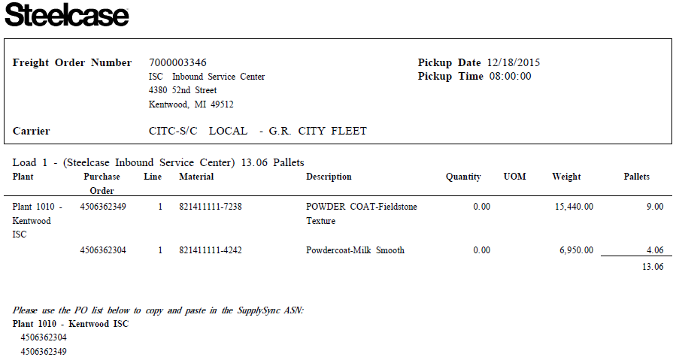

There are 4 key pieces of information within the pre-pick-up notification email:

1. The pick-up date and time is the estimated time the carrier will arrive to pick up the material.
2. The carrier section will display the SCAC code and name of the carrier picking up the material.
3. If there are multiple POs with different destination locations, the email will provide the sequence in which the POs need to be loaded on the trailer. This will help with the deliveries of the material to the different locations. In the above example, there is only one stop (Load 1). If there were additional destinations, there would be a section below titled “Load 2”. Load the material in order starting with loading “Load 1” first, “Load 2” second, etc.
4. The pallet quantity section is determined based on the part pack data provided by the supplier. If discrepancies are found with the pallet quantity, it is the responsibility of the supplier to send the correct part pack data to Steelcase Logistics team **inb-logistics@steelcase.com**.

**5.2 Expedite Purchase Order Shipments (Direct Materials & MRO)**

The expedite process requires both parties adhere to a standard process in tight time frames. Please ship per the revised PO and notification email you receive and answer the material planner’s questions.

The process to follow when a PO’s pickup date and/or delivery date needs to change:

* If the supplier needs to change the pickup date
* The supplier is to call/email the material planner and request the change.
* If the material planner agrees then he or she updates the PO.
* The material planner will likely request a pallet or box count and a weight from the supplier at this time.
  + The material planner contacts the inbound logistics team who will determine the best mode of transportation and email you the notification email.
* If the pickup is the same day as the request you will receive the email as soon as the PO has been planned for pickup. If the pickup is in the future, you will receive the notification email the day before around 3pm.
  + The supplier is to ship per the revised PO and notification email.
* If this is a FedEx ground or express air shipment the supplier will schedule the pickup with their FedEx process.

• If the material planner needs to expedite a PO.

* The material planner is to contact the supplier and ask for the best date and shipment detail (weight, pallet count or box count, dimensions).
* If the supplier agrees, then the material planner is to update the PO with the agreed upon dates and follow their process.
* Someone from the inbound logistics team will determine the best mode of transportation and email you the notification email.
* If the pickup is the same day as the request you will receive the email as soon as the PO has been planned for pickup. If the pickup is in the future, you will receive the notification email the day before around 3pm.
* The supplier is to ship per the revised PO and notification email.
* If this is a FedEx ground or express air shipment the supplier will schedule the pickup with their FedEx process.

**5.3 Expedite Vended Finished Goods Purchase Order Shipments**

The expedite process requires both parties adhere to a standard process in tight time frames. Please ship per the revised PO and notification email you receive and answer the material planner’s questions.

The process to follow when exceptions to your standard shipping schedule are needed:

* If the supplier needs to add/cancel/change a regularly scheduled pickup
  + The supplier is to email **inb-logistics@steelcase.com** with the below information 24-48 hours in advance when possible. Requests for same day changes will not be processed after 1pm for first shift operations.
* Supplier name (and location if multiple)
* Requested time of additional/canceled pickup
* If time change, what is original time, what is the desired time?
* Include FO # if available
  + A logistics planner will respond confirming change, and providing FO # and carrier for any additional shipments.
* If supplier needs to expedite/change shipment mode
* The supplier is to email **inb-logistics@steelcase.com** and their VFG event manager to inform them that an exception to standard shipment schedule is needed
* The supplier should submit the Transportation Request form to **inb-logistics@steelcase.com** with the necessary information.
* The logistics planner will provide shipping instructions on whether the product will need to be expedited and what method of transportation to use, whether it will go direct to a customer, or whether it will go on standard transit to the original destination.
* If the pickup is the same day as the request you will receive the email as soon as the PO has been planned for pickup. If the pickup is in the future, you will receive the notification email the day before around 3pm.
  + The supplier is to ship per the notification email.
* If Steelcase needs to expedite/change a schedule pickup, the Steelcase event manager needs to change the MAD date on a PO by following the change order process. This includes submitting a Sharepoint Freight Move Request form to the inbound logistics team who will tell the supplier how to ship the freight.
* If the pickup is the same day as the request you will receive the email as soon as the PO has been planned for pickup. If the pickup is in the future, you will receive the notification email the day before around 3pm.
  + The supplier is to ship per the notification email.
* Drop Shipments:
* If the shipment is less than 150 LBS, it can be sent FedEx parcel with the appropriate service level without being submitted to Steelcase Logistics. Do Not Use FedEx First Overnight. FedEx Ground, Standard Overnight, and Priority overnight are approved. FedEx Standard Overnight is to be used if the product is needed next day but a time is not specified. FedEx Priority is to be used if the product is needed by 10:30AM.
* For shipments over 150 LBS, the supplier must submit the transportation request form via email to **inb-logistics@steelcase.com** 48 hours prior to pick up for the transportation team to process.
* This includes shipments that were originally cut to ship direct and shipments where the Steelcase Event Planner has changed the destination address.
* The logistics planner will provide shipping instructions on whether the product will need to be expedited and what method of transportation to use.
* If the pickup is the same day as the request you will receive the email as soon as the PO has been planned for pickup. If the pickup is in the future, you will receive the notification email the day before around 3pm.
* The supplier is to ship per the notification email.
* MAD Changes:
  + If a Steelcase event manager needs to change the MAD date on a PO, they must submit a Sharepoint Freight Move Request form to the inbound logistics team who will dictate to the supplier how to ship the freight.
* If the pickup is the same day as the request you will receive the email as soon as the PO has been planned for pickup. If the pickup is in the future, you will receive the notification email the day before around 3pm.
* The supplier is to ship per the notification email.

**5.4 Modes / Types of Transportation**

FedEx Ground and FedEx Express shipments

• If your shipment is less than 150 LBs per package, and is not skidded, it can be shipped FedEx ground. FedEx ground shipments do NOT require a transportation request form to be submitted to the logistics team.

• The supplier is responsible for arranging pickup for all FedEx Ground and Express Air shipments. The ship notice received the day before will tell the supplier the service level to use.

• The supplier must use FedEx.com via the Steelcase FedEx Ship manager to arrange pickup. To get a Steelcase FedEx login ID request one by email @ **inb-logistics@steelcase.com**.

• The Steelcase Freight Order # must be placed in the Freight Order Number field when arranging pickup. The Freight Order # will be on the ship notice received the day before pickup. If shipping ground, use Steelcase purchase order # as you do not need to request transportation through the Steelcase logistics team.

• Print and use the air bill or label from FedEx.com ship admin portal. It will have all the information needed for proper billing and routing.

• LTL shipments must be palletized. If your material is not packed on a pallet and the ship notice instructs you to LTL, email **inb-logistics@steelcase.com** to change the mode.

• FedEx express shipments can be parcel (boxed) or palletized. If the material needs to be palletized the service level must be FedEx 1 Day or 2 day. The service level will be indicated on ship notice. If the shipment is palletized and the service level on the ship notice does not indicate FedEx 1 Day or FedEx 2 day, please email **inb-logistics@steelcase.com**.

FedEx Freight shipments

• FedEx Freight is an LTL carrier. All LTL pickups will be arranged by Steelcase logistics.

• The supplier is responsible for the BOL. The FedEx Uniform Straight Bill of Lading should be used and can be found online.

* Place the freight order number in the Shipper # field.
* Always mark the bill FedEx Freight Priority
* The Consignee Address is the address found on the ship notice next to “Load 1”.
* Never populate custom delivery window section.
* Mark Collect if product is going to Steelcase location, and Third Party if product is shipping to non-Steelcase location.
* Place PO Box 1967, Grand Rapids, MI 49501 in the “Bill Freight Charges To” section.

Common Carrier shipments

• Steelcase contracts pickups with many different FTL common carriers. The ship notice will provide the supplier the common carrier’s SCAC code and their name. If the supplier is responsible for creating an ASN the carrier’s SCAC code will need to be placed in the ASN field.

• The supplier is responsible for the BOL. The BOL is to include the carriers name and the Steelcase Freight Order #.

**5.4.1 Returnable Dunnage, how to request more?**

• The supplier emails ISC dunnage team with the dunnage request form.

* Please send to: **returnables@steelcase.com**

• The supplier must complete and send the order form in excel. A picture or PDF will not be accepted.

* The email needs to be sent 36 hours prior to delivery for city fleet deliveries and 72 hours for all other.

• The ISC/Returnables team will only respond back if they are out of something you are requesting.

• Below is an example of the dunnage request form:

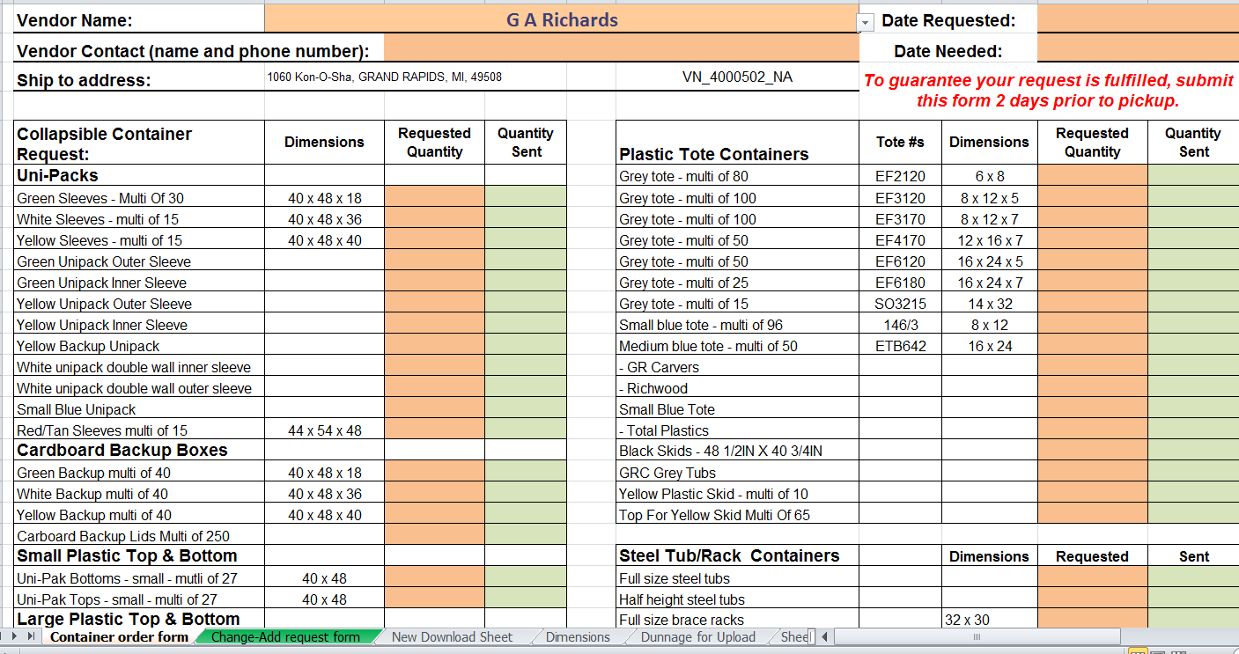

**5.4.3 Shipping PO Destinations at Steelcase Inc.**

• Product sorting will be determined between supplier and Steelcase distribution.

• Products must be loaded so labels face the rear of the trailer, completely visible by our un-loading personnel. Any additional information about the product should be positioned on the same side as the label for handling personnel to view.

• Products must be loaded by the supplier and secured in the trailer to prevent damage. Damages discovered upon arrival at Steelcase will become the responsibility of the supplier. Steelcase will work with the supplier to coordinate replacement of any damaged product.

**5.5 Product Labeling & Shipping Documentation Requirements.**

All shipments to Steelcase must follow this prescribed process and have proper labeling and

documentation for every container, pallet or pack.

The following are the requirements for all shipments to Steelcase North America.

Any supplier caused disruptions (e.g. product not available within a reasonable time of scheduled pickup) may result in a minimum charge to the supplier of $75.00 per hour for every hour departure time is missed rounded up to the next hour after 5 minutes. If the supplier is at fault for Steelcase to incur additional transportation and logistics costs over and above normal charges, such charges may be chargeable to the supplier. This could include, but not limited to, items such as shipment delays, split or incomplete shipments, freight damage caused by the supplier neglect. Specific Quality Management Notifications (QMN) may be written and applicable charges apply.

**Packing Slip**

All shipments from suppliers must include a packing slip and bill of lading. Packing lists can be attached to the product being shipped. It must be in an easily attainable and retrievable location without need for unpacking or opening of product container(s). If you are using Supply sync’s ASN process, you are required to print and use the Packing List and Pack Label offered in the Transportation Planning tool.

(See example below)

Required information includes:

• Supplier’s name and address from where shipment originates.

• Steelcase Plant Destination name and address. (Ship TO:)

• Steelcase Plant delivery door number.

• Purchase Order and line item being shipped.

• PO line item quantity being shipped.

• PO Due date.

• Revision level of product.

IF using Advance Shipment Notification process in SupplySync:

(Includes above information plus):

• Delivery Number (human readable and in 3 of 9 barcode format)

• External ID number

• Individual Pack ID number (Human readable and 3 of 9 Barcode format)

• Number of total packs on this shipment (ASN)

• Bill of Lading number

• Trailer number

• Carrier Name

• Plant ID number

• Destination Door Number

Supplier must use SupplySync provided Packing List when submitting ASN.

**Product Labeling / Pack Label**

All individual containers must contain the following information, unless otherwise noted in the Schedule of Product (SOP) document. The Pack Label must be attached to the ship unit (pack) using an adhesive back pouch. It should be facing outward, towards the opening of the trailer/truck as to facilitate scanning of the Pack Label barcode. If you are using Supply sync’s ASN process, you are required to print and use the Packing List and Pack Label offered in the Transportation Planning tool. *(See example below)*

* Steelcase material number (part number)
* Revision level
* Purchase Order & line item number
* Steelcase contact name (Purchase Group Contact) with phone number
* Quantity shipped
* Batch number, if applicable
* Shelf Life Expiration Date, if applicable
* Special storage instruction, if applicable
* Shelf life expiration date, if applicable.

Supplier must use SupplySync provided Packing Label when submitting ASN.

**Steelcase Finished Goods**

Requires precise loading requirements based on specific order conditions.

* The supplier is encouraged to use one skid for all small or miscellaneous orders, or as ASN permits.
* In certain instances the supplier will be requested to sort by P.O. number or by regional distribution center.
* All orders must have the pack labels properly attached facing the tail of the trailer.
* Labels must be visible, and barcode must overhang the end of the box (see photo below)
* Mock up orders are always to be loaded last, at the tail of the trailer, with the label copied/printed on “rocket red” paper (provided by your Steelcase FG Planner) in clear view.
* Trailers must arrive complete and on time (to Steelcase by 8 pm on due date to allow time to unload and scan by 10 pm)
* Special loading requirements will be stated in the Schedule of Product
* Under most circumstances, a Steelcase Finished Goods supplier will be required to sort shipments by P.O. number. Low quantity orders can be combined when required

Correct Label Placement



**Bill of Lading**

All Inbound shipments must have a uniform straight Bill of Lading. The signed BOL should be given to the driver when the freight is picked up.

Required information includes:

• Clearly, identify the Bill of Lading document.

• Type of BOL. (Uniform Straight, Air waybill…etc. ;)

• Consignee and complete address

• Destination door number Shipper complete address

• Document number

• Shipper complete address

• Document number

• Number of packages, descriptions and/or special markings

• Weight and class (rate) of each container with total weight of shipment

• Driver’s legible signature.

• Carrier (consignee) information

• Freight order number, when Steelcase plans inbound freight.   

• Bill of Lading document not provided in SupplySync.

## SECTION 6: gLOBAL REQUIREMENTS

**6.1 Global Business Standards**

Steelcase fully complies with the import and export laws of both the origination and destination countries and other relevant regulatory requirements. Steelcase requires that all suppliers act in accordance with U.S. regulations as well as those of the origination and destination countries.

The Master Purchase Agreement (MPA) requires the supplier to abide by all local, state and federal laws and regulations in the manufacture, sale and transport of goods sold to Steelcase. The MPA also requires the supplier to agree that it will not engage in any activity in the conduct of its’ business or its relations with its employees, shareholders, suppliers for customers prohibited by the U.S. Foreign Corrupt Practices Act of 1977.

The MPA also requires the supplier to indemnify Steelcase Inc. and hold it harmless from any claims, costs, liabilities, expenses, or fines incurred as a result of inaccuracies or omissions in the import/export, other trade regulation or certification or any other relevant requirement.

Supplier represents and agrees that it does, and for the duration of this agreement shall continue to, conduct its business and its relationships with its employees, shareholders, suppliers and customers per the applicable laws, regulations, and treaties, including United States laws and regulations as applicable to international treaties, regarding;

• Industrial espionage

• Child labor

• Force labor

• Antitrust

• Environmental, health and safety

• Import/export compliance

**6.2 Free Trade Agreements**

Free Trade Agreement Requirements

To comply with various Free Trade Agreements, Steelcase must obtain information from the manufacturer of the product to satisfy the country of origin requirements.

The Free Trade Agreement most used by Steelcase is USMCA for trade between the United States, Canada and Mexico. USMCA requires that Steelcase obtain certificates of origin from all suppliers of components used to produce finished products being sold by Steelcase in those countries. The Steelcase Global Trade Compliance department will contact suppliers to complete the necessary paperwork. Suppliers are required to assign the harmonized Tariff Code (HTS) numbers and the country of origin (CO) to all items. Also, the Preference Criteria Code (PCC) must be identified for all USMCA eligible items. If the supplier fails to provide the above information at the time Steelcase requests it, there may be fees assessed to the supplier for non-conformance

Any questions regarding U.S. Customs laws and USMCA can be addressed to the U.S. Department of Commerce, Office of USMCA and Inter-American Affairs.

WWW.CBP.GOV

**6.3 US Federal Government Requirements**

**BAA – Buy American Act / TAA – Trade Agreements Act**

Steelcase does sell product to the United States Federal Government and is required to prove percent content in our products to meet certain agreements like the BAA and TAA.

Suppliers will be required to tell Steelcase if their products apply to the BAA, TAA or both. The Steelcase Global Trade Compliance Team will contact the supplier with a list of products that need analysis.

**6.4** **Customs Trade Partner Against Terrorism (CTPAT) Requirements**

If Steelcase is the Importer of Record of the goods you provide, you will require all carriers and logistics providers that you use in connection with the performance of this Agreement to:

• maintain security programs that meet the requirements of the Customs Trade Partner Against Terrorism (CTPAT) program of U.S. Customs and Border Protection, or similar government supply chain security programs such as Operador Economico Autorizado (OEA – Mexico) or Authorized Economic Operator (AEO – Europe)

• provide all documentation relating to such programs as we may request, and

• allow our designated auditors and U.S. Customs and Border Protection auditors access to your or their facilities to evaluate your or their security programs.

If your carriers or logistics providers will be handling imports into the USA, they must be CTPAT certified.

If you or your carriers or logistics providers are CTPAT certified or certified within another government supply chain security program, you will provide us with evidence of your certification, and if you or they lose such certification for any reason, you will notify us in writing immediately. You must send any such notices to us at:

Steelcase Inc.

GH-4C-01

Global Trade Compliance

901 44th Street SE

Grand Rapids, MI 49508

**6.5** **Forced Labor Requirements**

Forced Labor occurs when individuals are compelled against their will to provide work or service through the use of force, fraud or coercion. This crime can happen both in the United States and overseas.

Customs & Border Protection (CBP) are responsible for preventing the entry of products made with forced labor into the US Market by investigating and acting upon allegations of forced labor in supply chains. Steelcase may need to work with the supplier(s) to verify that no forced labor is being used in their products (whole or in part) to the United States. Suppliers are required to help with this investigation. This means the suppliers will need to provide proof from ~~their TIER 1, 2, 3 and or 4~~ all lower tier suppliers that know of forced labor ~~is~~ being used in their materials.

## EXHIBITS

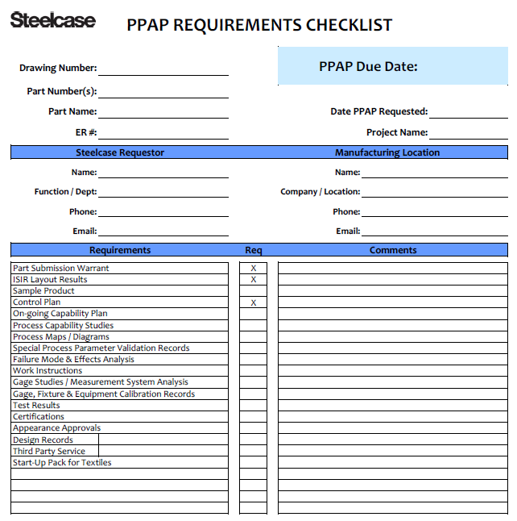

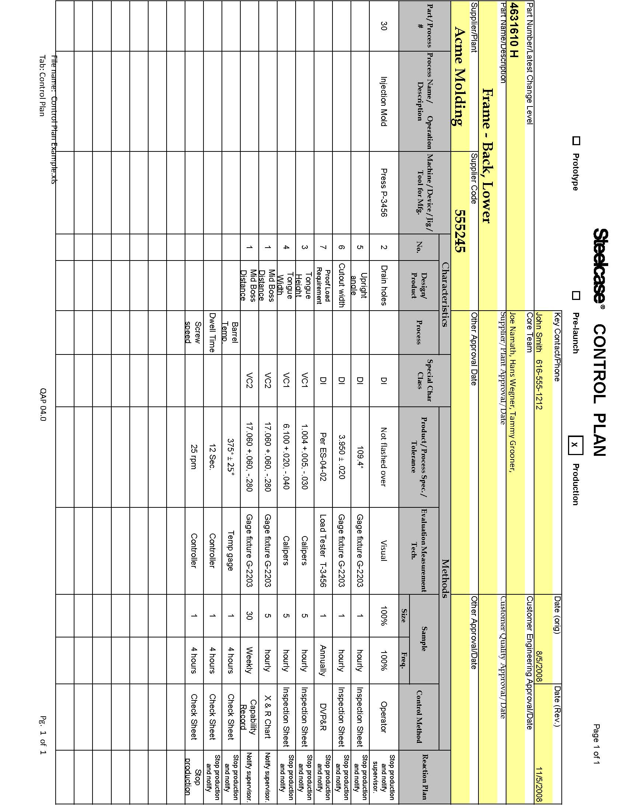

**Notification   200034168**

**Description    $300.00 Process Fee**

**Priority       QM   1          Very High**

**Reported by    JDoan                     Notification date   07/19/2008**

**Start deadline 07/19/2008                End deadline        08/10/2008**

**Vendor         555555          Fabricators Inc.**

**Material       8425070-9160    RAIL – ADJUSTABLE**

**________________________________________________________________________**

**Parts not to print.  Print specifies length to be 25.438 +/- .020 found**

**Parts running as high as 25.630            
Quantity rejected 10,800**

**P.O.'s being debited;**

**4502146078 line 1 – 3,000**

**4502143165 line 2 - 6,000**

**4502136849 Line 3 - 1,800**

**Total Qty 10,800**

**Costs per part 12,000 x $.111 = $1,332.00**

**Please send Corrective action to sqa@Steelcase.com by 8/2/08**

**________________________________________________________________________**

**Task   0001**

**Task            QM- T2 QMT1     14 Day Corrective Action Requirement**

**Responsible Person                                                             
Task text       Corrrective Actions required.**

**Status          TSRL**

**Planned start   04/16/2009 17:03:11**

**Planned end     05/08/2009 17:34:53                                                                             
\*\*\*\*\*\*\*\*\*\*\*\*\*\*\*\*\*\*\*\*\*\*\*\*\*\*\*\*\*\*\*\*\*\*\*\*\*\*\*\*\*\*\*\*\*\*\*\*\*\*\*\*\*\*\*\*\*\*\*\*\*\*\*\*\*\*\*\*\*\*\*\*\*\***

**\*The Corrective Action Response Should Include Answers To The Content**

**Below. Suppliers May Use This Form Or Equivalent To Reply.*                                                                                                 
Corrective Action Response Not Received Within 14 Calendar Days Of The**

**Origination Date Of The QMN May Be Subject To Additional Fees.**

**\*\*\*\*\*\*\*\*\*\*\*\*\*\*\*\*\*\*\*\*\*\*\*\*\*\*\*\*\*\*\*\*\*\*\*\*\*\*\*\*\*\*\*\*\*\*\*\*\*\*\*\*\*\*\*\*\*\*\*\*\*\*\*\*\*\*\*\*\*\*\*                                                            
*What is the Short-Term Corrective Action Response?_______________________        ___________________________________________________________________________________________________________________________________________________                                                       
What Is The Root Cause? (Please Consider Using The Following Methods To Determine Root Cause: 5 Whys, 8D, Pareto, Fishbone Diagram, etc.) ___________________________________________________________________________________________________________________________________________________**

**\*What Long-Term Permanent Corrective Actions Were Taken To Prevent                      Recurrence?(Please Consider Effects On 5M's: Materials, Methods, Manpower    Machines and Mother Nature.)                                                  ________________________________________________________________________________________________________________________________________________**

**\*What Error Proofing Methods Were Used?___________________________________     *What Impact Is There On Similar Products / Processes? ___________________     
 __________________________________________________________________________                            
*What Quality Documents Are Affected, Need Changing? (i.e. Manufacturing Control Plans, Work Instructions, etc.)  Please Attach Revised Documents with Your Response._______________________________________________________      
                             
*What Evidence of Effectiveness (measures) have been established?  ____________________________________________________________________________________________________________________________________________________                                
 *How Was Effectiveness Verified? ___________________________________________________________________________________________________________________                                
 Supplier Representative:_______________________________                                                     
 Date Submitted:________________________________________**

**Detail item      0001**

**Problem         QMD2 2251      Laminate/edgebanding/molding**

**Object part**

**Text            Various defects in sheets**

**Classification                                                                                                                                            End of report**

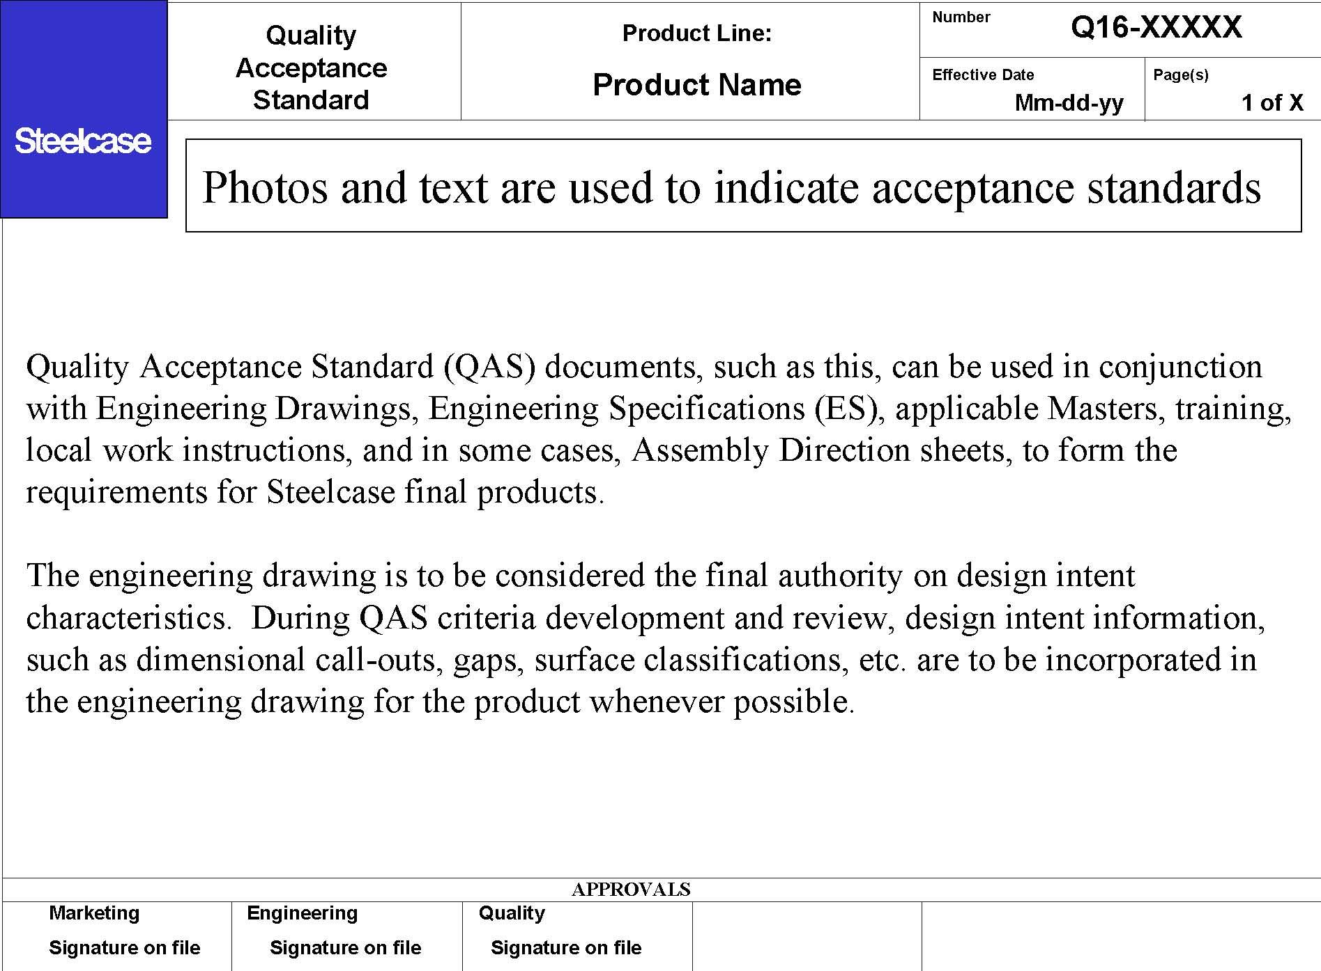

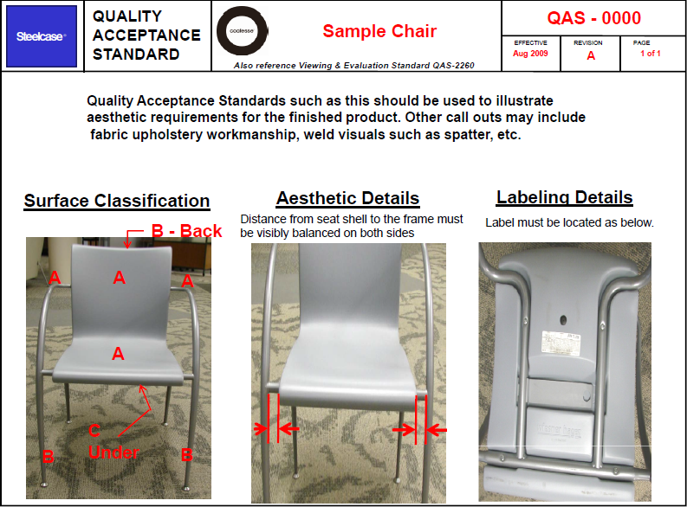

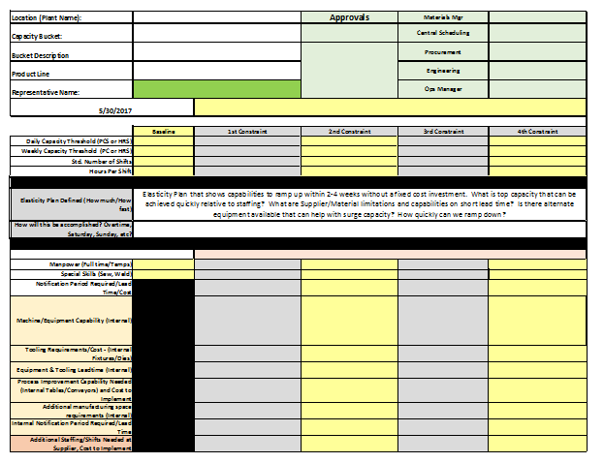

Long Term Capacity Plan Example

|  |  |  |  |  |  |  |  |  |  |  |  |
| --- | --- | --- | --- | --- | --- | --- | --- | --- | --- | --- | --- |
|  |  |  |  |  |  |  |  |  |  |  |  |
|  |  |  |  |  |  |  |
|  |  |  |  |  |  |  |  |  |  |  |  |